Tony Evers, Governor
Preston D. Cole, Secretary
Telephone 608-266-2621
Toll Free 1-888-936-7463
TTY Access via relay - 711

State of Wisconsin
DEPARTMENT OF NATURAL RESOURCES
Flambeau River State Forest
W1613 County Road W
Winter WI 54896
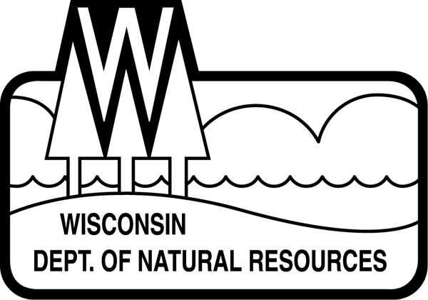

September 8, 2020

Dear Contractor:

This letter is regarding timber sales on the Flambeau River State Forest (FRSF). Prior to commencement of any timber sale activity, including road work, a S211- tax exemption form must be completed and be on file at the FRSF office.

If you do not know how to fill out the form or do not know which exemption applies to you, the instructions for filling out the form have been included with this letter. If the Purchaser needs further clarity, they should contact the Department of Revenue at DORSalesandUse@wisconsin.gov or by calling 608-266-2776.

The two most common exemptions from sales tax requirements for DNR timber sales are:
- Timber purchased for resale. See instructions for clarification. The Purchaser should check the box for “resale” and indicate “wholesale only” or “exempt sales only” in the space for seller’s permit number.

- Timber purchased for manufacturing by the Purchaser. See instructions for clarification. The purchaser should check the first box under the “manufacturing and biotechnology” heading that references tangible personal property.

If the Purchaser claims a different exemption, the Purchaser should check the box next to the exemption that applies on Form S-211.

Please complete the enclosed form and return it to the FRSF at the above address by September 28, 2020. If the form is not returned by September 28, 2020, you will be unable to start on your timber sale until the form is completed.

If you have any questions, please give me a call at 715-332-5271 ext. 106.

Sincerely,

Heidi Brunkow
Forester

